

***Bangladesh University of Business & Technology***

**PROJECT REPORT**

**Project Name: POS(parts of speech) GUIDE**

Course Title : SOFTWARE DEVELOPMENT - I

Course Code : CSE-100

**Submitted To** : **Md. Saifur Rahman**

Assistance Professor, Dept. of ***CSE***.

Teacher’s Signature :

**Developed By🡪**

|  |
| --- |
| **Name: Abu Rayhan Ahmad | ID : 14152103194** |
|  |
| **Name: Sushmita Debnath | ID : 14152103232** |
| **Name: Sudip Debnath | ID : 14152103231** |
| **Name: Hafiz Ahmed | ID : 14152103198** |
| **Name: Ahammad Akram | ID : 14152103216** |

***Date Of Submission : 14/05/2016***

**::INDEX::**

|  |  |  |  |
| --- | --- | --- | --- |
| **NAME** | | **Page** | |
| **About Parts of speech** | | **3** | |
| **Project Name** | | **4** | |
| **Objective of Project** | | **4** | |
| **Features of Project** | | **4** | |
| **Tools** | | **4** | |
| **Diagram / flowchart** | | **5** | |
| **Interface of project** | | **6-11** | |
| **Code / Program** | | **12-43** | |
| **Limitations of project** | | **44** | |
| **Conclusion / Summary** | | **44** | |

ABOUT PARTS OF SPEECH

In the English language, words can be considered as the smallest elements that have distinctive meanings. Based on their use and functions, words are categorized into several types or parts of speech. This article will offer definitions and examples for the 8 major parts of speech in English grammar: noun, pronoun, verb, adverb, adjective, conjunction, preposition, and interjection.

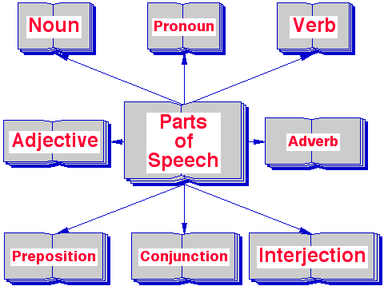

**PROJECT NAME:**  POS(PARTS OF SPEECH) GUIDE.

**Objective: Have fun playing our grammar games. Practice your English with word order games, parts of speech games and learn English as you race to choose parts of speech from given words. Enjoy these fun grammar games for kids. Find a range of free interactive exercises and practice activities that are perfect for helping students learn English. Learn about parts of speech with this fun game for kids. This games practice activity for students involves a series of challenges related to parts of speech. Find these types of words in sentences and understand when to use them properly. Press numbers for correct answer. Complete as many challenges as you can and have fun learning English!**

**Features:**

* Improve English grammar skill.
* Children can learning by playing this game.
* Multiplayer is enable for this game.

**Tools:**

* **C++**
* **Code Blocks**

**DIAGRAM / FLOWCHART:**

**P=Number of Player**

**If(Easy)**

**PTR++**

YES

NO

**Normal Process**

**Easy Process**

pt

NO

YES

**If(P==PTR)**

**Result**

**Interface:**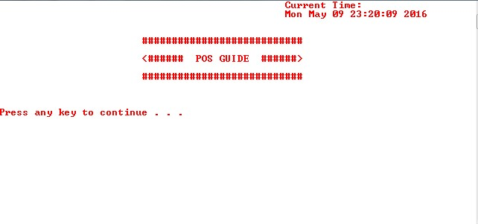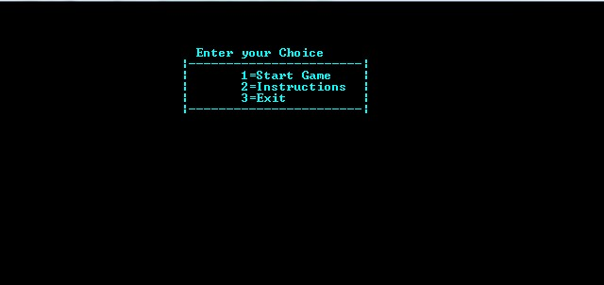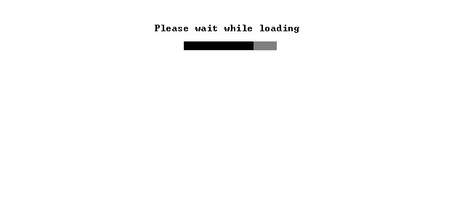

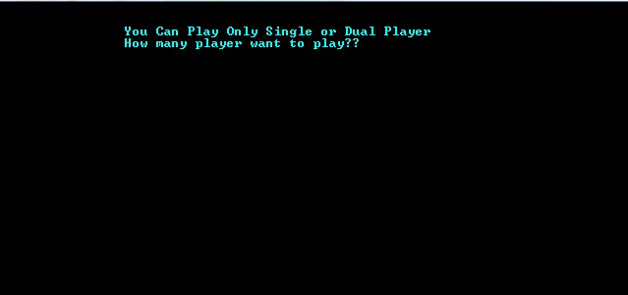

For Single Player:

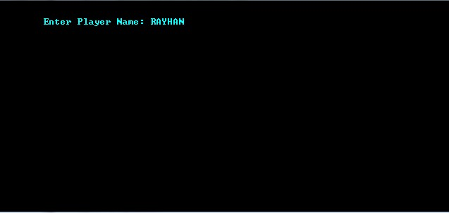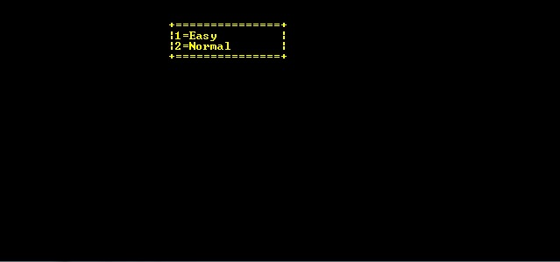

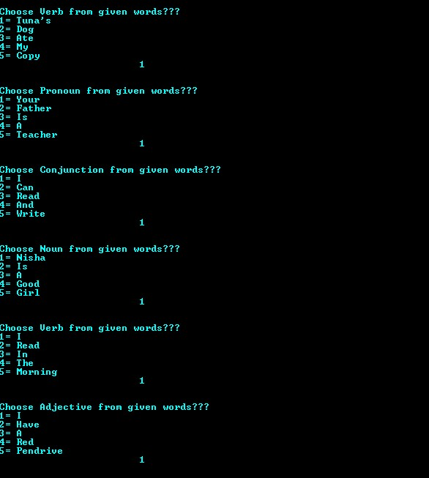

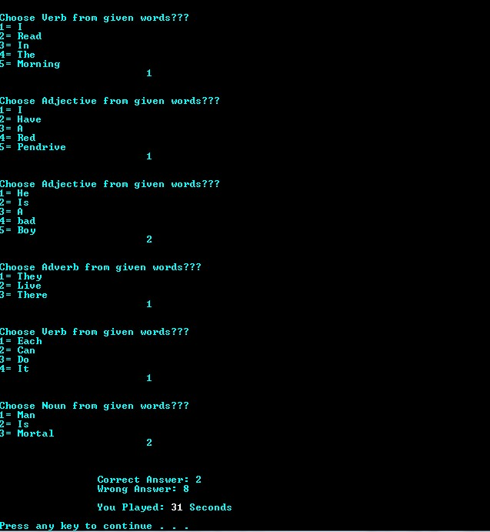

For Dual Player:

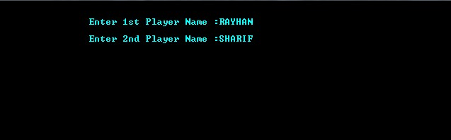

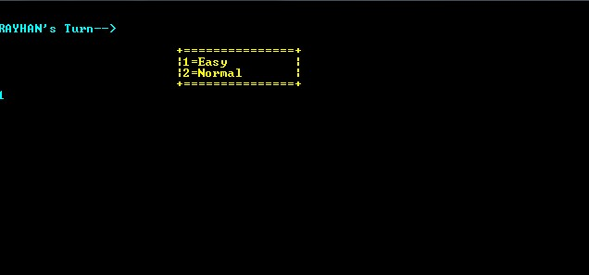

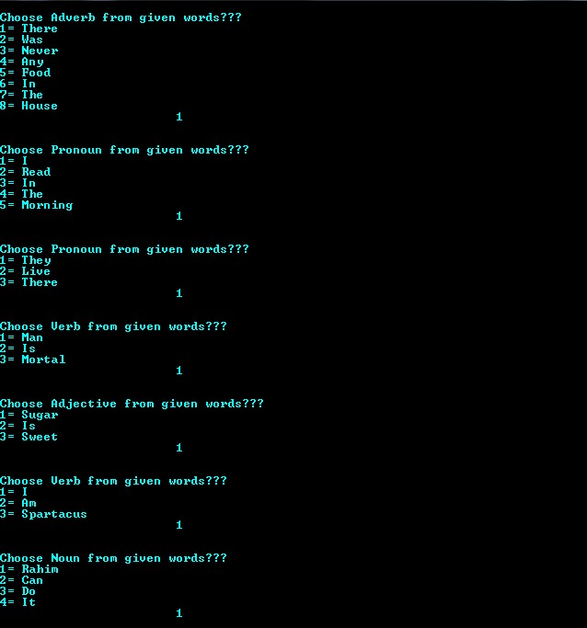

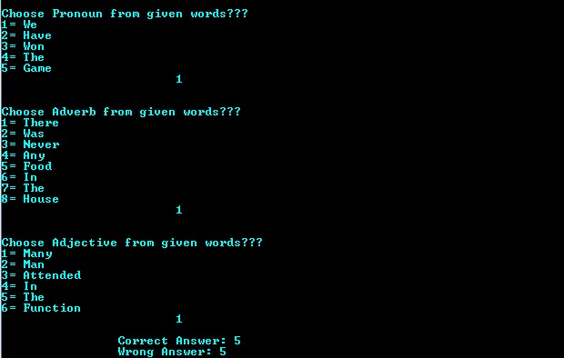

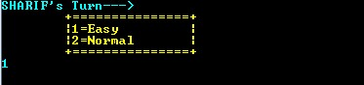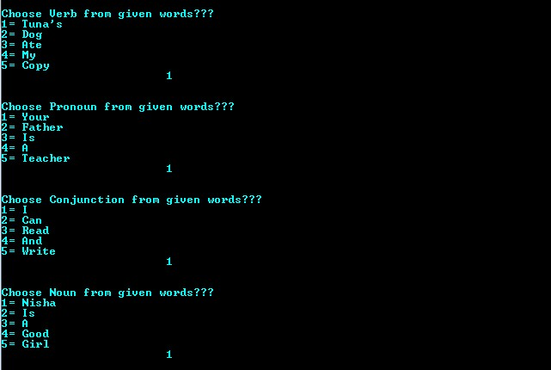

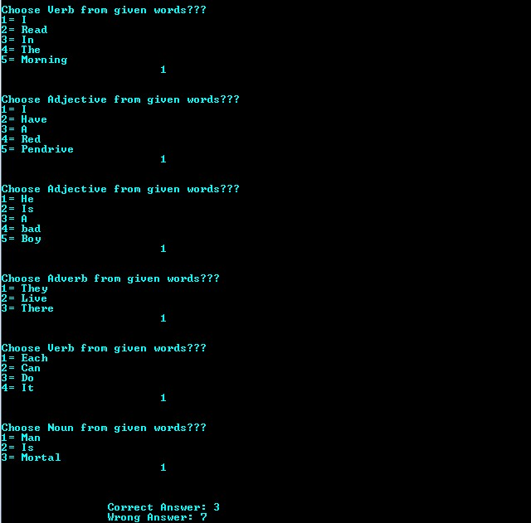

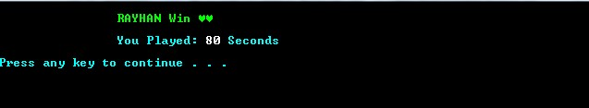

End Line For Both (Single or Dual):

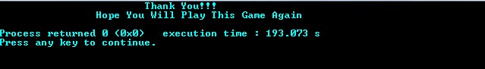

**Code /Program:**

#include<bits/stdc++.h>

#include<iostream>

#include<cstring>

#include<string>

#include<cstdio>

#include<cstdlib>

#include<windows.h>

using namespace std;

int j=1;

void colorPrint(int k)

{

HANDLE hConsole;

hConsole = GetStdHandle(STD_OUTPUT_HANDLE);

SetConsoleTextAttribute(hConsole, k);

}

int question_set1(int n)

{

int cor=0,fal=0,total=0,a;

/*EASY PORTION*/

if(n==1)

{

//1

cout<<endl;cout<<"Choose ";colorPrint(15);cout<<"Noun ";colorPrint(11);cout<<"from given words???"<<endl;

cout<<"1= Louis\n2= Is\n3= A\n4= Football\n5= Player\n";

cout<<"\t\t\t";

cin>>a;cout<<endl;

while(a>5)

{

cout<<"Wrong Choice\n";

cout<<"Enter Valid Number From Given Numbers\n";

cin>>a;

}

if(a==1)

{

system("COLOR A2");system("COLOR A2");system("COLOR A2");system("COLOR A2");cor++;system("COLOR 0B");

}

else

{

system("COLOR 4C");

system("COLOR 4C");system("COLOR 4C");system("COLOR 4C");system("COLOR 4C");fal++;system("COLOR 0B");

}

//2

cout<<endl;cout<<"Choose ";colorPrint(15);cout<<"Pronoun ";colorPrint(11);cout<<"from given words???"<<endl;

cout<<"1= She\n2= And\n3= Her\n4= Mother\n5= Have\n6= A\n7= Very\n8= Close\n9= Relationship\n";cout<<"\t\t\t";

cin>>a;cout<<endl;

while(a>9)

{

cout<<"Wrong Choice\n";

cout<<"Enter Valid Number From Given Numbers\n";

cin>>a;

}

if(a==1)

{

system("COLOR A2");system("COLOR A2");system("COLOR A2");system("COLOR A2");cor++;system("COLOR 0B");

}

else

{

system("COLOR 4C");

system("COLOR 4C");system("COLOR 4C");system("COLOR 4C");system("COLOR 4C");fal++;system("COLOR 0B");

}

//3

cout<<endl;cout<<"Choose ";colorPrint(15);cout<<"Preposition ";colorPrint(11);cout<<"from given words???"<<endl;

cout<<"1= Hasib\n2= Is\n3= In\n4= The\n5= House\n";cout<<"\t\t\t";

cin>>a;cout<<endl;

while(a>5)

{

cout<<"Wrong Choice\n";

cout<<"Enter Valid Number From Given Numbers\n";

cin>>a;

}

if(a==3)

{

system("COLOR A2");system("COLOR A2");system("COLOR A2");system("COLOR A2");cor++;system("COLOR 0B");

}

else

{

system("COLOR 4C");system("COLOR 4C");system("COLOR 4C");system("COLOR 4C");fal++;system("COLOR 0B");

}

//4

cout<<endl;cout<<"Choose ";colorPrint(15);cout<<"Verb ";colorPrint(11);cout<<"from given words???"<<endl;

cout<<"1= I\n2= Am\n3= Spartacus\n";cout<<"\t\t\t";

cin>>a;cout<<endl;

while(a>3)

{

cout<<"Wrong Choice\n";

cout<<"Enter Valid Number From Given Numbers\n";

cin>>a;

}

if(a==2)

{

system("COLOR A2");system("COLOR A2");system("COLOR A2");system("COLOR A2");cor++;system("COLOR 0B");

}

else

{

system("COLOR 4C");system("COLOR 4C");system("COLOR 4C");system("COLOR 4C");fal++;system("COLOR 0B");

}

//5

cout<<endl;cout<<"Choose ";colorPrint(15);cout<<"Verb ";colorPrint(11);cout<<"from given words???"<<endl;

cout<<"1= Rocks\n2= Are\n3= Hard\n";cout<<"\t\t\t";

cin>>a;cout<<endl;

while(a>3)

{

cout<<"Wrong Choice\n";

cout<<"Enter Valid Number From Given Numbers\n";

cin>>a;

}

if(a==2)

{

system("COLOR A2");system("COLOR A2");system("COLOR A2");system("COLOR A2");cor++;system("COLOR 0B");

}

else

{

system("COLOR 4C");system("COLOR 4C");system("COLOR 4C");system("COLOR 4C");fal++;system("COLOR 0B");

}

//6

cout<<endl;cout<<"Choose ";colorPrint(15);cout<<"Adverb ";colorPrint(11);cout<<"from given words???"<<endl;

cout<<"1= There\n2= was\n3= Never\n4= Any\n5= Food\n6= In\n7= The\n8= House\n";cout<<"\t\t\t";

cin>>a;cout<<endl;

while(a>8)

{

cout<<"Wrong Choice\n";

cout<<"Enter Valid Number From Given Numbers\n";

cin>>a;

}

if(a==3)

{

system("COLOR A2");system("COLOR A2");system("COLOR A2");system("COLOR A2");cor++;system("COLOR 0B");

}

else

{

system("COLOR 4C");system("COLOR 4C");system("COLOR 4C");system("COLOR 4C");fal++;system("COLOR 0B");

}

//7

cout<<endl;cout<<"Choose ";colorPrint(15);cout<<"Adjective ";colorPrint(11);cout<<"from given words???"<<endl;

cout<<"1= Kamrul\n2= Is\n3= A\n4= Good\n5= Boy\n";cout<<"\t\t\t";

cin>>a;cout<<endl;

while(a>5)

{

cout<<"Wrong Choice\n";

cout<<"Enter Valid Number From Given Numbers\n";

cin>>a;

}

if(a==4)

{

system("COLOR A2");system("COLOR A2");system("COLOR A2");system("COLOR A2");cor++;system("COLOR 0B");

}

else

{

system("COLOR 4C");system("COLOR 4C");system("COLOR 4C");system("COLOR 4C");fal++;system("COLOR 0B");

}

//8

cout<<endl;cout<<"Choose ";colorPrint(15);cout<<"Adjective ";colorPrint(11);cout<<"from given words???"<<endl;

cout<<"1= That\n2= Must\n3= Be\n4= A\n5= Very\n6= Hot\n7= Fire\n";

cout<<"\t\t\t";

cin>>a;cout<<endl;

while(a>7)

{

cout<<"Wrong Choice\n";

cout<<"Enter Valid Number From Given Numbers\n";

cin>>a;

}

if(a==6)

{

system("COLOR A2");system("COLOR A2");system("COLOR A2");system("COLOR A2");cor++;system("COLOR 0B");

}

else

{

system("COLOR 4C");system("COLOR 4C");system("COLOR 4C");system("COLOR 4C");fal++;system("COLOR 0B");

}

//9

cout<<endl;cout<<"Choose ";colorPrint(15);cout<<"Interjection ";colorPrint(11);cout<<"from given words???"<<endl;

cout<<"1= Hurrah!\n2= We\n3= Have\n4= Won\n5= The\n6= Game\n";

cout<<"\t\t\t";

cin>>a;cout<<endl;

while(a>6)

{

cout<<"Wrong Choice\n";

cout<<"Enter Valid Number From Given Numbers\n";

cin>>a;

}

if(a==1)

{

system("COLOR A2");system("COLOR A2");system("COLOR A2");system("COLOR A2");cor++;system("COLOR 0B");

}

else

{

system("COLOR 4C");system("COLOR 4C");system("COLOR 4C");system("COLOR 4C");fal++;system("COLOR 0B");

}

//10

cout<<endl;cout<<"Choose ";colorPrint(15);cout<<"Adjective ";colorPrint(11);cout<<"from given words???"<<endl;

cout<<"1= They\n2= Have\n3= Much\n4= Rice\n";

cout<<"\t\t\t";

cin>>a;cout<<endl;

while(a>6)

{

cout<<"Wrong Choice\n";

cout<<"Enter Valid Number From Given Numbers\n";

cin>>a;

}

if(a==3)

{

system("COLOR A2");system("COLOR A2");system("COLOR A2");system("COLOR A2");cor++;system("COLOR 0B");

}

else

{

system("COLOR 4C");system("COLOR 4C");system("COLOR 4C");system("COLOR 4C");fal++;system("COLOR 0B");

}

}

//NORMAL PORTION

else if(n==2)

{

//1

cout<<endl;cout<<"Choose ";colorPrint(15);cout<<"Verb ";colorPrint(11);cout<<"from given words???"<<endl;

cout<<"1= People\n2= learn\n3= From\n4= Their\n5= Mistakes\n";cout<<"\t\t\t";

cin>>a;cout<<endl;

while(a>5)

{

cout<<"Wrong Choice\n";

cout<<"Enter Valid Number From Given Numbers\n";

cin>>a;

}

if(a==2)

{

system("COLOR A2");system("COLOR A2");system("COLOR A2");system("COLOR A2");cor++;system("COLOR 0B");

}

else

{

system("COLOR 4C");system("COLOR 4C");system("COLOR 4C");system("COLOR 4C");fal++;system("COLOR 0B");

}

//2

cout<<endl;

cout<<"Choose ";colorPrint(15);cout<<"Verb ";colorPrint(11);cout<<"from given words???"<<endl;

cout<<"1= Mother\n2= Gave\n3= Me\n4= A\n5= Card\n6= For\n7= My\n8= Birthday\n";cout<<"\t\t\t";

cin>>a;cout<<endl;

while(a>8)

{

cout<<"Wrong Choice\n";

cout<<"Enter Valid Number From Given Numbers\n";

cin>>a;

}

if(a==2)

{

system("COLOR A2");system("COLOR A2");system("COLOR A2");system("COLOR A2");cor++;system("COLOR 0B");

}

else

{

system("COLOR 4C");system("COLOR 4C");system("COLOR 4C");system("COLOR 4C");fal++;system("COLOR 0B");

}

//3

cout<<endl;

cout<<"Choose ";colorPrint(15);cout<<"Adjective ";colorPrint(11);cout<<"from given words???"<<endl;

cout<<"1= The\n2= New\n3= Mail\n4= Carrier\n5= Finally\n6= Arrived\n";cout<<"\t\t\t";

cin>>a;

cout<<endl;

while(a>6)

{

cout<<"Wrong Choice\n";

cout<<"Enter Valid Number From Given Numbers\n";

cin>>a;

}

if(a==2)

{

system("COLOR A2");system("COLOR A2");system("COLOR A2");system("COLOR A2");cor++;system("COLOR 0B");

}

else

{

system("COLOR 4C");system("COLOR 4C");system("COLOR 4C");system("COLOR 4C");fal++;system("COLOR 0B");

}

//4

cout<<endl;cout<<"Choose ";colorPrint(15);cout<<"Adverb ";colorPrint(11);cout<<"from given words???"<<endl;

cout<<"1= Last\n2= Night,\n3= The\n4= Shone\n5= Brightly\n6= Over\n7= The\n8= Homes\n9= In\n10= My\n11= Neighborhood\n";cout<<"\t\t\t";

cin>>a;cout<<endl;

while(a>11)

{

cout<<"Wrong Choice\n";

cout<<"Enter Valid Number From Given Numbers\n";

cin>>a;

}

if(a==5)

{

system("COLOR A2");system("COLOR A2");system("COLOR A2");system("COLOR A2");cor++;system("COLOR 0B");

}

else

{

system("COLOR 4C");system("COLOR 4C");system("COLOR 4C");system("COLOR 4C");fal++;system("COLOR 0B");

}

//5

cout<<endl;cout<<"Choose ";colorPrint(15);cout<<"Adverb ";colorPrint(11);cout<<"from given words???"<<endl;

cout<<"1= Neela\n2= Writes\n3=Slowly\n";cout<<"\t\t\t";

cin>>a;cout<<endl;

while(a>3)

{

cout<<"Wrong Choice\n";

cout<<"Enter Valid Number From Given Numbers\n";

cin>>a;

}

if(a==3)

{

system("COLOR A2");system("COLOR A2");system("COLOR A2");system("COLOR A2");cor++;system("COLOR 0B");

}

else

{

system("COLOR 4C");system("COLOR 4C");system("COLOR 4C");system("COLOR 4C");fal++;system("COLOR 0B");

}

//6

cout<<endl;cout<<"Choose ";colorPrint(15);cout<<"Adjective ";colorPrint(11);cout<<"from given words???"<<endl;

cout<<"1= Few\n2= Candidates\n3= Were\n4= Selected\n5= For\n6= The\n7= Jobs\n";cout<<"\t\t\t";

cin>>a;cout<<endl;

while(a>7)

{

cout<<"Wrong Choice\n";

cout<<"Enter Valid Number From Given Numbers\n";

cin>>a;

}

if(a==1)

{

system("COLOR A2");system("COLOR A2");system("COLOR A2");system("COLOR A2");cor++;system("COLOR 0B");

}

else

{

system("COLOR 4C");system("COLOR 4C");system("COLOR 4C");system("COLOR 4C");fal++;system("COLOR 0B");

}

//7

cout<<endl;cout<<"Choose ";colorPrint(15);cout<<"Verb ";colorPrint(11);cout<<"from given words???"<<endl;

cout<<"1= I\n2= Told\n3= Them\n4= To\n5= Come\n6= Here\n";cout<<"\t\t\t";

cin>>a;cout<<endl;

while(a>6)

{

cout<<"Wrong Choice\n";

cout<<"Enter Valid Number From Given Numbers\n";

cin>>a;

}

if(a==2)

{

system("COLOR A2");system("COLOR A2");system("COLOR A2");system("COLOR A2");cor++;system("COLOR 0B");

}

else

{

system("COLOR 4C");system("COLOR 4C");system("COLOR 4C");system("COLOR 4C");fal++;system("COLOR 0B");

}

//8

cout<<endl;cout<<"Choose ";colorPrint(15);cout<<"Pronoun ";colorPrint(11);cout<<"from given words???"<<endl;

cout<<"1= she\n2= Is\n3= A\n4= Sleeping\n";cout<<"\t\t\t";

cin>>a;cout<<endl;

while(a>4)

{

cout<<"Wrong Choice\n";

cout<<"Enter Valid Number From Given Numbers\n";

cin>>a;

}

if(a==1)

{

system("COLOR A2");system("COLOR A2");system("COLOR A2");system("COLOR A2");cor++;system("COLOR 0B");

}

else

{

system("COLOR 4C");system("COLOR 4C");system("COLOR 4C");system("COLOR 4C");fal++;system("COLOR 0B");

}

//9

cout<<endl;cout<<"Choose ";colorPrint(15);cout<<"Conjunction ";colorPrint(11);cout<<"from given words???"<<endl;

cout<<"1= He\n2= Studied\n3= Hard\n4= And\n5= Passed\n6= The\n7= Examination\n";cout<<"\t\t\t";

cin>>a;cout<<endl;

while(a>7)

{

cout<<"Wrong Choice\n";

cout<<"Enter Valid Number From Given Numbers\n";

cin>>a;

}

if(a==4)

{

system("COLOR A2");system("COLOR A2");system("COLOR A2");system("COLOR A2");cor++;system("COLOR 0B");

}

else

{

system("COLOR 4C");system("COLOR 4C");system("COLOR 4C");system("COLOR 4C");fal++;system("COLOR 0B");

}

//10

cout<<endl;cout<<"Choose ";colorPrint(15);cout<<"Preposition ";colorPrint(11);cout<<"from given words???"<<endl;

cout<<"1= The\n2= Book\n3= Is\n4= On\n5= The\n6= Table\n";cout<<"\t\t\t";

cin>>a;cout<<endl;

while(a>6)

{

cout<<"Wrong Choice\n";

cout<<"Enter Valid Number From Given Numbers\n";

cin>>a;

}

if(a==4)

{

system("COLOR A2");system("COLOR A2");system("COLOR A2");system("COLOR A2");cor++;system("COLOR 0B");

}

else

{

system("COLOR 4C");system("COLOR 4C");system("COLOR 4C");system("COLOR 4C");fal++;system("COLOR 0B");

}

}

total=(cor-fal)*100;

//freopen("output.txt","w",stdout);

cout<<"\n\n\t\t\xB2\xB2\xB2\xB2\xB2\xB2\xB2 > Correct Answer: "<<cor<<endl;

cout<<"\t\t\xB2\xB2\xB2\xB2\xB2\xB2\xB2 > Wrong Answer: "<<fal<<endl;

return total;

}

//Question Set-2

int question_set2(int n)

{

int cor=0,fal=0,total=0,a;

//EASY PORTION

if(n==1)

{

//1

cout<<endl;cout<<"Choose ";colorPrint(15);cout<<"Verb ";colorPrint(11);cout<<"from given words???"<<endl;

cout<<"1= Tuna's\n2= Dog\n3= Ate\n4= My\n5= Copy\n";cout<<"\t\t\t";

cin>>a;cout<<endl;

while(a>5)

{

cout<<"Wrong Choice\n";

cout<<"Enter Valid Number From Given Numbers\n";

cin>>a;

}

if(a==3)

{

system("COLOR A2");system("COLOR A2");system("COLOR A2");system("COLOR A2");cor++;system("COLOR 0B");

}

else

{

system("COLOR 4C");system("COLOR 4C");system("COLOR 4C");system("COLOR 4C");fal++;system("COLOR 0B");

}

//2

cout<<endl;cout<<"Choose ";colorPrint(15);cout<<"Pronoun ";colorPrint(11);cout<<"from given words???"<<endl;

cout<<"1= Your\n2= Father\n3= Is\n4= A\n5= Teacher\n";cout<<"\t\t\t";

cin>>a;cout<<endl;

while(a>5)

{

cout<<"Wrong Choice\n";

cout<<"Enter Valid Number From Given Numbers\n";

cin>>a;

}

if(a==1)

{

system("COLOR A2");system("COLOR A2");system("COLOR A2");system("COLOR A2");cor++;system("COLOR 0B");

}

else

{

system("COLOR 4C");system("COLOR 4C");system("COLOR 4C");system("COLOR 4C");fal++;system("COLOR 0B");

}

//3

cout<<endl;cout<<"Choose ";colorPrint(15);cout<<"Conjunction ";colorPrint(11);cout<<"from given words???"<<endl;

cout<<"1= I\n2= Can\n3= Read\n4= And\n5= Write\n";cout<<"\t\t\t";

cin>>a;cout<<endl;

while(a>5)

{

cout<<"Wrong Choice\n";

cout<<"Enter Valid Number From Given Numbers\n";

cin>>a;

}

if(a==4)

{

system("COLOR A2");system("COLOR A2");system("COLOR A2");system("COLOR A2");cor++;system("COLOR 0B");

}

else

{

system("COLOR 4C");system("COLOR 4C");system("COLOR 4C");system("COLOR 4C");fal++;system("COLOR 0B");

}

//4

cout<<endl;cout<<"Choose ";colorPrint(15);cout<<"Noun ";colorPrint(11);cout<<"from given words???"<<endl;

cout<<"1= Nisha\n2= Is\n3= A\n4= Good\n5= Girl\n";cout<<"\t\t\t";

cin>>a;cout<<endl;

while(a>5)

{

cout<<"Wrong Choice\n";

cout<<"Enter Valid Number From Given Numbers\n";

cin>>a;

}

if(a==1)

{

system("COLOR A2");system("COLOR A2");system("COLOR A2");system("COLOR A2");cor++;system("COLOR 0B");

}

else

{

system("COLOR 4C");system("COLOR 4C");system("COLOR 4C");system("COLOR 4C");fal++;system("COLOR 0B");

}

//5

cout<<endl;cout<<"Choose ";colorPrint(15);cout<<"Verb ";colorPrint(11);cout<<"from given words???"<<endl;

cout<<"1= I\n2= Read\n3= In\n4= The\n5= Morning\n";cout<<"\t\t\t";

cin>>a;cout<<endl;

while(a>5)

{

cout<<"Wrong Choice\n";

cout<<"Enter Valid Number From Given Numbers\n";

cin>>a;

}

if(a==2)

{

system("COLOR A2");system("COLOR A2");system("COLOR A2");system("COLOR A2");cor++;system("COLOR 0B");

}

else

{

system("COLOR 4C");system("COLOR 4C");system("COLOR 4C");system("COLOR 4C");fal++;system("COLOR 0B");

}

//6

cout<<endl;cout<<"Choose ";colorPrint(15);cout<<"Adjective ";colorPrint(11);cout<<"from given words???"<<endl;

cout<<"1= I\n2= Have\n3= A\n4= Red\n5= Pendrive\n";cout<<"\t\t\t";

cin>>a;cout<<endl;

while(a>5)

{

cout<<"Wrong Choice\n";

cout<<"Enter Valid Number From Given Numbers\n";

cin>>a;

}

if(a==4)

{

system("COLOR A2");system("COLOR A2");system("COLOR A2");system("COLOR A2");cor++;system("COLOR 0B");

}

else

{

system("COLOR 4C");system("COLOR 4C");system("COLOR 4C");system("COLOR 4C");fal++;system("COLOR 0B");

}

//7

cout<<endl;cout<<"Choose ";colorPrint(15);cout<<"Adjective ";colorPrint(11);cout<<"from given words???"<<endl;

cout<<"1= He\n2= Is\n3= A\n4= bad\n5= Boy\n";cout<<"\t\t\t";

cin>>a;cout<<endl;

while(a>5)

{

cout<<"Wrong Choice\n";

cout<<"Enter Valid Number From Given Numbers\n";

cin>>a;

}

if(a==4)

{

system("COLOR A2");system("COLOR A2");system("COLOR A2");system("COLOR A2");cor++;system("COLOR 0B");

}

else

{

system("COLOR 4C");system("COLOR 4C");system("COLOR 4C");system("COLOR 4C");fal++;system("COLOR 0B");

}

//8

cout<<endl;cout<<"Choose ";colorPrint(15);cout<<"Adverb ";colorPrint(11);cout<<"from given words???"<<endl;

cout<<"1= They\n2= Live\n3= There\n";cout<<"\t\t\t";

cin>>a;cout<<endl;

while(a>3)

{

cout<<"Wrong Choice\n";

cout<<"Enter Valid Number From Given Numbers\n";

cin>>a;

}

if(a==3)

{

system("COLOR A2");system("COLOR A2");system("COLOR A2");system("COLOR A2");cor++;system("COLOR 0B");

}

else

{

system("COLOR 4C");system("COLOR 4C");system("COLOR 4C");system("COLOR 4C");fal++;system("COLOR 0B");

}

//9

cout<<endl;cout<<"Choose ";colorPrint(15);cout<<"Verb ";colorPrint(11);cout<<"from given words???"<<endl;

cout<<"1= Each\n2= Can\n3= Do\n4= It\n";cout<<"\t\t\t";

cin>>a;cout<<endl;

while(a>4)

{

cout<<"Wrong Choice\n";

cout<<"Enter Valid Number From Given Numbers\n";

cin>>a;

}

if(a==3)

{

system("COLOR A2");system("COLOR A2");system("COLOR A2");system("COLOR A2");cor++;system("COLOR 0B");

}

else

{

system("COLOR 4C");system("COLOR 4C");system("COLOR 4C");system("COLOR 4C");fal++;system("COLOR 0B");

}

//10

cout<<endl;cout<<"Choose ";colorPrint(15);cout<<"Noun ";colorPrint(11);cout<<"from given words???"<<endl;

cout<<"1= Man\n2= Is\n3= Mortal\n";cout<<"\t\t\t";

cin>>a;cout<<endl;

while(a>3)

{

cout<<"Wrong Choice\n";

cout<<"Enter Valid Number From Given Numbers\n";

cin>>a;

}

if(a==1)

{

system("COLOR A2");system("COLOR A2");system("COLOR A2");system("COLOR A2");cor++;system("COLOR 0B");

}

else

{

system("COLOR 4C");system("COLOR 4C");system("COLOR 4C");system("COLOR 4C");fal++;system("COLOR 0B");

}

}

//NORMAL PORTION

else if(n==2)

{

//1

cout<<endl;cout<<"Choose ";colorPrint(15);cout<<"Pronoun ";colorPrint(11);cout<<"from given words???"<<endl;

cout<<"1= Last\n2= Night,\n3= The\n4= Shone\n5= Brightly\n6= Over\n7= The\n8= Homes\n9= In\n10= My\n11= Neighborhood\n";cout<<"\t\t\t";

cin>>a;cout<<endl;

while(a>11)

{

cout<<"Wrong Choice\n";

cout<<"Enter Valid Number From Given Numbers\n";

cin>>a;

}

if(a==10)

{

system("COLOR A2");system("COLOR A2");system("COLOR A2");system("COLOR A2");cor++;system("COLOR 0B");

}

else

{

system("COLOR 4C");system("COLOR 4C");system("COLOR 4C");system("COLOR 4C");fal++;system("COLOR 0B");

}

//2

cout<<endl;cout<<"Choose ";colorPrint(15);cout<<"Preposition ";colorPrint(11);cout<<"from given words???"<<endl;

cout<<"1= There\n2= Was\n3= Never\n4= Any\n5= Food\n6= In\n7= The\n8= House\n";cout<<"\t\t\t";

cin>>a;cout<<endl;

while(a>8)

{

cout<<"Wrong Choice\n";

cout<<"Enter Valid Number From Given Numbers\n";

cin>>a;

}

if(a==6)

{

system("COLOR A2");system("COLOR A2");system("COLOR A2");system("COLOR A2");cor++;system("COLOR 0B");

}

else

{

system("COLOR 4C");system("COLOR 4C");system("COLOR 4C");system("COLOR 4C");fal++;system("COLOR 0B");

}

//3

cout<<endl;cout<<"Choose ";colorPrint(15);cout<<"Adjective ";colorPrint(11);cout<<"from given words???"<<endl;

cout<<"1= Man\n2= Is\n3= Mortal\n";cout<<"\t\t\t";

cin>>a;cout<<endl;

while(a>3)

{

cout<<"Wrong Choice\n";

cout<<"Enter Valid Number From Given Numbers\n";

cin>>a;

}

if(a==3)

{

system("COLOR A2");system("COLOR A2");system("COLOR A2");system("COLOR A2");cor++;system("COLOR 0B");

}

else

{

system("COLOR 4C");system("COLOR 4C");system("COLOR 4C");system("COLOR 4C");fal++;system("COLOR 0B");

}

//4

cout<<endl;cout<<"Choose ";colorPrint(15);cout<<"Preposition ";colorPrint(11);cout<<"from given words???"<<endl;

cout<<"1= Programmers\n2= Of\n3= 29th\n4= Intake\n5= Section\n6= 5\n7= Are\n8= Good\n9= Coder\n";cout<<"\t\t\t";

cin>>a;cout<<endl;

while(a>9)

{

cout<<"Wrong Choice\n";

cout<<"Enter Valid Number From Given Numbers\n";

cin>>a;

}

if(a==2)

{

system("COLOR A2");system("COLOR A2");system("COLOR A2");system("COLOR A2");cor++;system("COLOR 0B");

}

else

{

system("COLOR 4C");system("COLOR 4C");system("COLOR 4C");system("COLOR 4C");fal++;system("COLOR 0B");

}

//5

cout<<endl;cout<<"Choose ";colorPrint(15);cout<<"Preposition ";colorPrint(11);cout<<"from given words???"<<endl;

cout<<"1= The\n2= Book\n3= Is\n4= On\n5= The\n6= Table\n";cout<<"\t\t\t";

cin>>a;cout<<endl;

while(a>6)

{

cout<<"Wrong Choice\n";

cout<<"Enter Valid Number From Given Numbers\n";

cin>>a;

}

if(a==4)

{

system("COLOR A2");system("COLOR A2");system("COLOR A2");system("COLOR A2");cor++;system("COLOR 0B");

}

else

{

system("COLOR 4C");system("COLOR 4C");system("COLOR 4C");system("COLOR 4C");fal++;system("COLOR 0B");

}

//6

cout<<endl;cout<<"Choose ";colorPrint(15);cout<<"Adverb ";colorPrint(11);cout<<"from given words???"<<endl;

cout<<"1= There\n2= Was\n3= Never\n4= Any\n5= Food\n6= In\n7= The\n8= House\n";cout<<"\t\t\t";

cin>>a;cout<<endl;

while(a>8)

{

cout<<"Wrong Choice\n";

cout<<"Enter Valid Number From Given Numbers\n";

cin>>a;

}

if(a==3)

{

system("COLOR A2");system("COLOR A2");system("COLOR A2");system("COLOR A2");cor++;system("COLOR 0B");

}

else

{

system("COLOR 4C");system("COLOR 4C");system("COLOR 4C");system("COLOR 4C");fal++;system("COLOR 0B");

}

//7

cout<<endl;cout<<"Choose ";colorPrint(15);cout<<"Preposition ";colorPrint(11);cout<<"from given words???"<<endl;

cout<<"1= He\n2= Seemed\n3= Sorry\n4= Since\n5= He\n6= Almost\n8= Immediately\n9= Apologized\n10= To\n11= Us\n";cout<<"\t\t\t";

cin>>a;cout<<endl;

while(a>11)

{

cout<<"Wrong Choice\n";

cout<<"Enter Valid Number From Given Numbers\n";

cin>>a;

}

if(a==4)

{

system("COLOR A2");system("COLOR A2");system("COLOR A2");system("COLOR A2");cor++;system("COLOR 0B");

}

else

{

system("COLOR 4C");system("COLOR 4C");system("COLOR 4C");system("COLOR 4C");fal++;system("COLOR 0B");

}

//8

cout<<endl;cout<<"Choose ";colorPrint(15);cout<<"Interjection ";colorPrint(11);cout<<"from given words???"<<endl;

cout<<"1= Oh!\n2= What\n3= A\n4= Beautiful\n5= Flower\n";cout<<"\t\t\t";

cin>>a;cout<<endl;

while(a>5)

{

cout<<"Wrong Choice\n";

cout<<"Enter Valid Number From Given Numbers\n";

cin>>a;

}

if(a==1)

{

system("COLOR A2");system("COLOR A2");system("COLOR A2");system("COLOR A2");cor++;system("COLOR 0B");

}

else

{

system("COLOR 4C");system("COLOR 4C");system("COLOR 4C");system("COLOR 4C");fal++;system("COLOR 0B");

}

//9

cout<<endl;cout<<"Choose ";colorPrint(15);cout<<"Adjective ";colorPrint(11);cout<<"from given words???"<<endl;

cout<<"1= Few\n2= Candidates\n3= Were\n4= Selected\n5= For\n6= The\n7= Jobs\n";cout<<"\t\t\t";

cin>>a;cout<<endl;

while(a>7)

{

cout<<"Wrong Choice\n";

cout<<"Enter Valid Number From Given Numbers\n";

cin>>a;

}

if(a==1)

{

system("COLOR A2");system("COLOR A2");system("COLOR A2");system("COLOR A2");cor++;system("COLOR 0B");

}

else

{

system("COLOR 4C");system("COLOR 4C");system("COLOR 4C");system("COLOR 4C");fal++;system("COLOR 0B");

}

//10

cout<<endl;cout<<"Choose ";colorPrint(15);cout<<"Pronoun ";colorPrint(11);cout<<"from given words???"<<endl;

cout<<"1= The\n2= Garden\n3= Is\n4= In\n5= Front\n6= of\n7= My\n8= House\n";cout<<"\t\t\t";

cin>>a;cout<<endl;

while(a>8)

{

cout<<"Wrong Choice\n";

cout<<"Enter Valid Number From Given Numbers\n";

cin>>a;

}

if(a==7)

{

system("COLOR A2");system("COLOR A2");system("COLOR A2");system("COLOR A2");cor++;system("COLOR 0B");

}

else

{

system("COLOR 4C");system("COLOR 4C");system("COLOR 4C");system("COLOR 4C");fal++;system("COLOR 0B");

}

}

//freopen("output.txt","w",stdout);

total=(cor-fal)*100;

cout<<"\n\n\t\t\xB2\xB2\xB2\xB2\xB2\xB2\xB2 > Correct Answer: "<<cor<<endl;

cout<<"\t\t\xB2\xB2\xB2\xB2\xB2\xB2\xB2 > Wrong Answer: "<<fal<<endl;

return total;

}

//Question Se-3

int question_set3(int n)

{

int cor=0,fal=0,total=0,a;

//EASY PORTION

if(n==1)

{

//1

cout<<endl;cout<<"Choose ";colorPrint(15);cout<<"Adverb ";colorPrint(11);cout<<"from given words???"<<endl;

cout<<"1= There\n2= Was\n3= Never\n4= Any\n5= Food\n6= In\n7= The\n8= House\n";cout<<"\t\t\t";

cin>>a;cout<<endl;

while(a>8)

{

cout<<"Wrong Choice\n";

cout<<"Enter Valid Number From Given Numbers\n";

cin>>a;

}

if(a==3)

{

system("COLOR A2");system("COLOR A2");system("COLOR A2");system("COLOR A2");cor++;system("COLOR 0B");

}

else

{

system("COLOR 4C");system("COLOR 4C");system("COLOR 4C");system("COLOR 4C");fal++;system("COLOR 0B");

}

//2

cout<<endl;cout<<"Choose ";colorPrint(15);cout<<"Pronoun ";colorPrint(11);cout<<"from given words???"<<endl;

cout<<"1= I\n2= Read\n3= In\n4= The\n5= Morning\n";cout<<"\t\t\t";

cin>>a;cout<<endl;

while(a>5)

{

cout<<"Wrong Choice\n";

cout<<"Enter Valid Number From Given Numbers\n";

cin>>a;

}

if(a==1)

{

system("COLOR A2");system("COLOR A2");system("COLOR A2");system("COLOR A2");cor++;system("COLOR 0B");

}

else

{

system("COLOR 4C");system("COLOR 4C");system("COLOR 4C");system("COLOR 4C");fal++;system("COLOR 0B");

}

//3

cout<<endl;cout<<"Choose ";colorPrint(15);cout<<"Pronoun ";colorPrint(11);cout<<"from given words???"<<endl;

cout<<"1= They\n2= Live\n3= There\n";cout<<"\t\t\t";

cin>>a;cout<<endl;

while(a>3)

{

cout<<"Wrong Choice\n";

cout<<"Enter Valid Number From Given Numbers\n";

cin>>a;

}

if(a==1)

{

system("COLOR A2");system("COLOR A2");system("COLOR A2");system("COLOR A2");cor++;system("COLOR 0B");

}

else

{

system("COLOR 4C");system("COLOR 4C");system("COLOR 4C");system("COLOR 4C");fal++;system("COLOR 0B");

}

//4

cout<<endl;cout<<"Choose ";colorPrint(15);cout<<"Verb ";colorPrint(11);cout<<"from given words???"<<endl;

cout<<"1= Man\n2= Is\n3= Mortal\n";cout<<"\t\t\t";

cin>>a;cout<<endl;

while(a>3)

{

cout<<"Wrong Choice\n";

cout<<"Enter Valid Number From Given Numbers\n";

cin>>a;

}

if(a==2)

{

system("COLOR A2");system("COLOR A2");system("COLOR A2");system("COLOR A2");cor++;system("COLOR 0B");

}

else

{

system("COLOR 4C");system("COLOR 4C");system("COLOR 4C");system("COLOR 4C");fal++;system("COLOR 0B");

}

//5

cout<<endl;cout<<"Choose ";colorPrint(15);cout<<"Adjective ";colorPrint(11);cout<<"from given words???"<<endl;

cout<<"1= Sugar\n2= Is\n3= Sweet\n";cout<<"\t\t\t";

cin>>a;cout<<endl;

while(a>3)

{

cout<<"Wrong Choice\n";

cout<<"Enter Valid Number From Given Numbers\n";

cin>>a;

}

if(a==3)

{

system("COLOR A2");system("COLOR A2");system("COLOR A2");system("COLOR A2");cor++;system("COLOR 0B");

}

else

{

system("COLOR 4C");system("COLOR 4C");system("COLOR 4C");system("COLOR 4C");fal++;system("COLOR 0B");

}

//6

cout<<endl;cout<<"Choose ";colorPrint(15);cout<<"Verb ";colorPrint(11);cout<<"from given words???"<<endl;

cout<<"1= I\n2= Am\n3= Spartacus\n";cout<<"\t\t\t";

cin>>a;cout<<endl;

while(a>3)

{

cout<<"Wrong Choice\n";

cout<<"Enter Valid Number From Given Numbers\n";

cin>>a;

}

if(a==2)

{

system("COLOR A2");system("COLOR A2");system("COLOR A2");system("COLOR A2");cor++;system("COLOR 0B");

}

else

{

system("COLOR 4C");system("COLOR 4C");system("COLOR 4C");system("COLOR 4C");fal++;system("COLOR 0B");

}

//7

cout<<endl;cout<<"Choose ";colorPrint(15);cout<<"Noun ";colorPrint(11);cout<<"from given words???"<<endl;

cout<<"1= Rahim\n2= Can\n3= Do\n4= It\n";cout<<"\t\t\t";

cin>>a;cout<<endl;

while(a>4)

{

cout<<"Wrong Choice\n";

cout<<"Enter Valid Number From Given Numbers\n";

cin>>a;

}

if(a==1)

{

system("COLOR A2");system("COLOR A2");system("COLOR A2");system("COLOR A2");cor++;system("COLOR 0B");

}

else

{

system("COLOR 4C");system("COLOR 4C");system("COLOR 4C");system("COLOR 4C");fal++;system("COLOR 0B");

}

//8

cout<<endl;cout<<"Choose ";colorPrint(15);cout<<"Pronoun ";colorPrint(11);cout<<"from given words???"<<endl;

cout<<"1= We\n2= Have\n3= Won\n4= The\n5= Game\n";cout<<"\t\t\t";

cin>>a;cout<<endl;

while(a>5)

{

cout<<"Wrong Choice\n";

cout<<"Enter Valid Number From Given Numbers\n";

cin>>a;

}

if(a==1)

{

system("COLOR A2");system("COLOR A2");system("COLOR A2");system("COLOR A2");cor++;system("COLOR 0B");

}

else

{

system("COLOR 4C");system("COLOR 4C");system("COLOR 4C");system("COLOR 4C");fal++;system("COLOR 0B");

}

//9

cout<<endl;cout<<"Choose ";colorPrint(15);cout<<"Adverb ";colorPrint(11);cout<<"from given words???"<<endl;

cout<<"1= There\n2= Was\n3= Never\n4= Any\n5= Food\n6= In\n7= The\n8= House\n";cout<<"\t\t\t";

cin>>a;cout<<endl;

while(a>8)

{

cout<<"Wrong Choice\n";

cout<<"Enter Valid Number From Given Numbers\n";

cin>>a;

}

if(a==3)

{

system("COLOR A2");system("COLOR A2");system("COLOR A2");system("COLOR A2");cor++;system("COLOR 0B");

}

else

{

system("COLOR 4C");system("COLOR 4C");system("COLOR 4C");system("COLOR 4C");fal++;system("COLOR 0B");

}

//10

cout<<endl;cout<<"Choose ";colorPrint(15);cout<<"Adjective ";colorPrint(11);cout<<"from given words???"<<endl;

cout<<"1= Many\n2= Man\n3= Attended\n4= In\n5= The\n6= Function\n";cout<<"\t\t\t";

cin>>a;cout<<endl;

while(a>6)

{

cout<<"Wrong Choice\n";

cout<<"Enter Valid Number From Given Numbers\n";

cin>>a;

}

if(a==1)

{

system("COLOR A2");system("COLOR A2");system("COLOR A2");system("COLOR A2");cor++;system("COLOR 0B");

}

else

{

system("COLOR 4C");system("COLOR 4C");system("COLOR 4C");system("COLOR 4C");fal++;system("COLOR 0B");

}

}

//NORMAL PORTION

else if(n==2)

{

//1

cout<<endl;cout<<"Choose ";colorPrint(15);cout<<"Adjective ";colorPrint(11);cout<<"from given words???"<<endl;

cout<<"1= Last\n2= Night,\n3= The\n4= Shone\n5= Brightly\n6= Over\n7= The\n8= Homes\n9= In\n10= My\n11= Neighborhood\n";cout<<"\t\t\t";

cin>>a;cout<<endl;

while(a>11)

{

cout<<"Wrong Choice\n";

cout<<"Enter Valid Number From Given Numbers\n";

cin>>a;

}

if(a==1)

{

system("COLOR A2");system("COLOR A2");system("COLOR A2");system("COLOR A2");cor++;system("COLOR 0B");

}

else

{

system("COLOR 4C");system("COLOR 4C");system("COLOR 4C");system("COLOR 4C");fal++;system("COLOR 0B");

}

//2

cout<<endl;cout<<"Choose ";colorPrint(15);cout<<"Conjunction ";colorPrint(11);cout<<"from given words???"<<endl;

cout<<"1= Not\n2= Only\n3= Karim\n4= But\n5= Also\n6= His\n7= Brothers\n8= Have\n9= Done\n10= This\n";cout<<"\t\t\t";

cin>>a;cout<<endl;

while(a>10)

{

cout<<"Wrong Choice\n";

cout<<"Enter Valid Number From Given Numbers\n";

cin>>a;

}

if(a==4)

{

system("COLOR A2");system("COLOR A2");system("COLOR A2");system("COLOR A2");cor++;system("COLOR 0B");

}

else

{

system("COLOR 4C");system("COLOR 4C");system("COLOR 4C");system("COLOR 4C");fal++;system("COLOR 0B");

}

//3

cout<<endl;cout<<"Choose ";colorPrint(15);cout<<"Preposition ";colorPrint(11);cout<<"from given words???"<<endl;

cout<<"1= Many\n2= Man\n3= Attended\n4= In\n5= The\n6= Function\n";cout<<"\t\t\t";

cin>>a;cout<<endl;

while(a>6)

{

cout<<"Wrong Choice\n";

cout<<"Enter Valid Number From Given Numbers\n";

cin>>a;

}

if(a==4)

{

system("COLOR A2");system("COLOR A2");system("COLOR A2");system("COLOR A2");cor++;system("COLOR 0B");

}

else

{

system("COLOR 4C");system("COLOR 4C");system("COLOR 4C");system("COLOR 4C");fal++;system("COLOR 0B");

}

//4

cout<<endl;cout<<"Choose ";colorPrint(15);cout<<"Adjective ";colorPrint(11);cout<<"from given words???"<<endl;

cout<<"1= I\n2= Am\n3= A\n4= Good\n5= Boy\n";cout<<"\t\t\t";

cin>>a;cout<<endl;

while(a>5)

{

cout<<"Wrong Choice\n";

cout<<"Enter Valid Number From Given Numbers\n";

cin>>a;

}

if(a==4)

{

system("COLOR A2");system("COLOR A2");system("COLOR A2");system("COLOR A2");cor++;system("COLOR 0B");

}

else

{

system("COLOR 4C");system("COLOR 4C");system("COLOR 4C");system("COLOR 4C");fal++;system("COLOR 0B");

}

//5

cout<<endl;cout<<"Choose ";colorPrint(15);cout<<"Verb ";colorPrint(11);cout<<"from given words???"<<endl;

cout<<"1= The\n2= New\n3= Mail\n4= Finally\n5= Arrived\n";cout<<"\t\t\t";

cin>>a;cout<<endl;

while(a>5)

{

cout<<"Wrong Choice\n";

cout<<"Enter Valid Number From Given Numbers\n";

cin>>a;

}

if(a==4)

{

system("COLOR A2");system("COLOR A2");system("COLOR A2");system("COLOR A2");cor++;system("COLOR 0B");

}

else

{

system("COLOR 4C");system("COLOR 4C");system("COLOR 4C");system("COLOR 4C");fal++;system("COLOR 0B");

}

//6

cout<<endl;cout<<"Choose ";colorPrint(15);cout<<"Interjection ";colorPrint(11);cout<<"from given words???"<<endl;

cout<<"1= Wow!\n2= The\n3= Girl\n4= is\n5= Look\n6= So\n8= Beautiful\n";cout<<"\t\t\t";

cin>>a;cout<<endl;

while(a>8)

{

cout<<"Wrong Choice\n";

cout<<"Enter Valid Number From Given Numbers\n";

cin>>a;

}

if(a==1)

{

system("COLOR A2");system("COLOR A2");system("COLOR A2");system("COLOR A2");cor++;system("COLOR 0B");

}

else

{

system("COLOR 4C");system("COLOR 4C");system("COLOR 4C");system("COLOR 4C");fal++;system("COLOR 0B");

}

//7

cout<<endl;cout<<"Choose ";colorPrint(15);cout<<"Preposition ";colorPrint(11);cout<<"from given words???"<<endl;

cout<<"1= He\n2= Seemed\n3= Sorry\n4= Since\n5= He\n6= Almost\n8= Immediately\n9= Apologized\n10= To\n11= Us\n";cout<<"\t\t\t";

cin>>a;cout<<endl;

while(a>11)

{

cout<<"Wrong Choice\n";

cout<<"Enter Valid Number From Given Numbers\n";

cin>>a;

}

if(a==4)

{

system("COLOR A2");system("COLOR A2");system("COLOR A2");system("COLOR A2");cor++;system("COLOR 0B");

}

else

{

system("COLOR 4C");system("COLOR 4C");system("COLOR 4C");system("COLOR 4C");fal++;system("COLOR 0B");

}

//8

cout<<endl;cout<<"Choose ";colorPrint(15);cout<<"Preposition ";colorPrint(11);cout<<"from given words???"<<endl;

cout<<"1= I\n2= Read\n3= In\n4= The\n5= Morning\n";cout<<"\t\t\t";

cin>>a;cout<<endl;

while(a>5)

{

cout<<"Wrong Choice\n";

cout<<"Enter Valid Number From Given Numbers\n";

cin>>a;

}

if(a==3)

{

system("COLOR A2");system("COLOR A2");system("COLOR A2");system("COLOR A2");cor++;system("COLOR 0B");

}

else

{

system("COLOR 4C");system("COLOR 4C");system("COLOR 4C");system("COLOR 4C");fal++;system("COLOR 0B");

}

//9

cout<<"Is There Any Adverb In This Sentence?? Enter(1=Yes or 2=No)\n";

cout<<" Mom wanted the answer, but we had had no reply from our daughter or son"<<endl;

cout<<"1= Yes\n2= No\n";

cin>>a;

cout<<endl<<endl;

while(a>2)

{

cout<<"Wrong Choice\n";

cout<<"Enter Valid Number From Given Numbers\n";

cin>>a;

}

if(a==2)

{

system("COLOR A2");system("COLOR A2");system("COLOR A2");system("COLOR A2");cor++;system("COLOR 0B");

}

else

{

system("COLOR 4C");system("COLOR 4C");system("COLOR 4C");system("COLOR 4C");fal++;system("COLOR 0B");

}

//10

cout<<endl;cout<<"Choose ";colorPrint(15);cout<<"Preposition ";colorPrint(11);cout<<"from given words???"<<endl;

cout<<"1= There\n2= Was\n3= Never\n4= Any\n5= Food\n6= In\n7= The\n8= House\n";cout<<"\t\t\t";

cin>>a;cout<<endl;

while(a>8)

{

cout<<"Wrong Choice\n";

cout<<"Enter Valid Number From Given Numbers\n";

cin>>a;

}

if(a==6)

{

system("COLOR A2");system("COLOR A2");system("COLOR A2");system("COLOR A2");cor++;system("COLOR 0B");

}

else

{

system("COLOR 4C");system("COLOR 4C");system("COLOR 4C");system("COLOR 4C");fal++;system("COLOR 0B");

}

}

total=(cor-fal)*100;

//freopen("output.txt","w",stdout);

cout<<"\t\t\xB2\xB2\xB2\xB2\xB2\xB2\xB2 > Correct Answer: "<<cor<<endl;

cout<<"\t\t\xB2\xB2\xB2\xB2\xB2\xB2\xB2 > Wrong Answer: "<<fal<<endl;

return total;

}

/*int question_set4(int n)

{

if(n==1){}

else if(n==2){}

else{}

}

int question_set5(int n)

{

if(n==1){}

else if(n==2){}

else{}

}

*/

int main()

{

time_t tim;

time_t star = 0;

time_t end = 0;

time_t elapsed = 0; //create variable of time_t

time(&tim);

int start,dif,p1=0,p2=0;

cout <<"\t\t\t\t\t\tCurrent Time:\n\t\t\t\t\t\t"<< ctime(&tim)<<endl<<endl;

star = time(NULL);

system("COLOR FC");

cout<<"\t\t\t\xB2\xB2\xB2\xB2\xB2\xB2\xB2\xB2\xB2\xB2\xB2\xB2\xB2\xB2\xB2\xB2\xB2\xB2\xB2\xB2\xB2\xB2\xB2\xB2\xB2\xB2\xB2\xB2\xB2\xB2\xB2"<<endl<<endl;

cout<<"\t\t\t\xB2 POS(parts of speech) GUIDE \xB2\t\t\n"<<endl;

cout<<"\t\t\t\xB2\xB2\xB2\xB2\xB2\xB2\xB2\xB2\xB2\xB2\xB2\xB2\xB2\xB2\xB2\xB2\xB2\xB2\xB2\xB2\xB2\xB2\xB2\xB2\xB2\xB2\xB2\xB2\xB2\xB2\xB2\n\n\n\n\n\n\n\n\n";

system("PAUSE");

system("cls");

system("COLOR 0B");

cout<<"\n\n\n\t\t\t Enter your Choice(1-3)\t\t\n"<<endl;

cout<<"\t\t\t\xB2\xB2\xB2\xB2\xB2\xB2\xB2\xB2\xB2\xB2\xB2\xB2\xB2\xB2\xB2\xB2\xB2\xB2\xB2\xB2\xB2\xB2\xB2\xB2\xB2\xB2\xB2\xB2\xB2\xB2\xB2\xB2\xB2\t\t"<<endl;

cout<<"\t\t\t|\t1=Start Game\t\t|\t\t"<<endl;

cout<<"\t\t\t|\t2=Instructions\t\t|\t\t"<<endl;

cout<<"\t\t\t|\t3=Exit\t\t\t|\t\t"<<endl;

cout<<"\t\t\t\xB2\xB2\xB2\xB2\xB2\xB2\xB2\xB2\xB2\xB2\xB2\xB2\xB2\xB2\xB2\xB2\xB2\xB2\xB2\xB2\xB2\xB2\xB2\xB2\xB2\xB2\xB2\xB2\xB2\xB2\xB2\xB2\xB2\t\t"<<endl;

cout<<"\t\t\t\n";

cin>>start;

while(start>3)

{

cout<<"Wrong Choice\n";

cout<<"Enter Valid Number From Given Numbers\n";

cin>>start;

}

system("cls");

system("color F0");

cout<<"\n\n\n\t\t\t Please wait while loading\n\n";

char f=177, g=219;

cout<<"\t\t\t\t";

for (int i=0;i<=15;i++)

cout<<f;

cout<<"\r";

cout<<"\t\t\t\t";

for (int i=0;i<=15;i++)

{

cout<<g;

for (int j=0;j<=1e8;j++); //You can also use sleep function instead of for loop

}

system("cls");

system("COLOR 0B");

char a[100],b[100],c[100];

int x,i,j,l[100],le[100],y,z,len[100],k,q,r,s,t,sum=0,sum1=0,sum2=0,p=0,flag=0;

while(1)

{

if(start==1)

{

cout<<"\n\n";

cout<<"\t\tYou Can Play Only Single or Dual Player(1 or 2)\n";

cout<<"\t\tHow many player want to play??"<<endl;

cin>>x;

while(x>2)

{

cout<<"Wrong Choice\n";

cout<<"You Can Play Only Single or Dual Player (1 or 2)\n";

cin>>x;

}

system("cls");

if(x==1)

{

cout<<"\n\n";

cout<<"\t\xB2\xB2\xB2\xB2\xB2\xB2\xB2 > Enter Player Name: ";

cin>>a;

system("cls");

cout<<"\n\n";

colorPrint(14);

cout<<"\t\t\tEnter Your Choice(1 or 2)\n";

cout<<"\t\t\t\xB2\xB2\xB2\xB2\xB2\xB2\xB2\xB2\xB2\xB2\xB2\xB2\xB2\xB2\xB2\xB2\xB2\t\n";

cout<<"\t\t\t| 1=Easy\t|\t\n";

cout<<"\t\t\t| 2=Normal\t|\t\n";

cout<<"\t\t\t\xB2\xB2\xB2\xB2\xB2\xB2\xB2\xB2\xB2\xB2\xB2\xB2\xB2\xB2\xB2\xB2\xB2\t\n";

colorPrint(11);

cin>>dif;

while(dif>2)

{

cout<<"Wrong Choice\n";

cout<<"You Can Choose From Given Numbers Not"<<dif<<"\n";

cin>>dif;

}

cout<<"\n\n";

system("cls");

y=strlen(a);

for(i=0; i<y; i++)

{

sum+=a[i];

}

//cout<<"Player : "<<sum<<endl;

if(sum%3==0)

{

//cout<<"Q1"<<endl;

p=question_set1(dif);

flag=3;

cout<<"\t\tTotal Score: "<<p<<endl;

}

else if(sum%3==1)

{

//cout<<"Q2"<<endl;

p=question_set2(dif);

flag=3;

cout<<"\t\tTotal Score: "<<p<<endl;

}

else

{

// cout<<"Q3"<<endl;

p=question_set3(dif);

flag=3;

cout<<"\t\tTotal Score: "<<p<<endl;

}

}

else if(x==2)

{

cout<<"\n\n";

//cout<<"CAPITAL LATTER IS BEST : "<<endl<<endl;

cout<<"\t\t\xB2\xB2\xB2\xB2 > Enter 1st Player Name :";

cin>>b;

cout<<"\n";

cout<<"\t\t\xB2\xB2\xB2\xB2 > Enter 2nd Player Name :";

cin>>c;

z=strlen(b);

j=strlen(c);

system("cls");

for(i=0; i<z; i++)

{

sum1=sum1+b[i];

}

for(i=0; i<j; i++)

{

sum2=sum2+c[i];

}

//cout<<"Player 1: "<<sum1<<endl;

//cout<<"Player 2: "<<sum2<<endl;

cout<<"\n\t\t"<<b<<"'s Turn \xB2\xB2\xB2\xB2 >\n\n";

colorPrint(14);

cout<<"\t\t\tEnter Your Choice(1 or 2)\n";

cout<<"\t\t\t\xB2\xB2\xB2\xB2\xB2\xB2\xB2\xB2\xB2\xB2\xB2\xB2\xB2\xB2\xB2\xB2\xB2\t\n";

cout<<"\t\t\t| 1=Easy\t|\t\n";

cout<<"\t\t\t| 2=Normal\t|\t\n";

cout<<"\t\t\t\xB2\xB2\xB2\xB2\xB2\xB2\xB2\xB2\xB2\xB2\xB2\xB2\xB2\xB2\xB2\xB2\xB2\t\n";

colorPrint(11);

cin>>dif;

while(dif>2)

{

cout<<"Wrong Choice\n";

cout<<"You Can Choose Given Numbers Not"<<dif<<"\n";

cin>>dif;

}

system("cls");

if(sum1%3==0)

{

p1=question_set1(dif);

flag=1;

cout<<"\t\tTotal Score: "<<p1<<endl;

}

else if(sum1%3==2)

{

p1=question_set2(dif);

flag=1;

cout<<"\t\tTotal Score: "<<p1<<endl;

}

else

{

p1=question_set3(dif);

flag=1;

cout<<"\t\tTotal Score: "<<p1<<endl;

}

cout<<"\n\n\n\n";

system("PAUSE");

system("cls");

cout<<"\n\n\t\t"<<c<<"'s Turn \xB2\xB2\xB2\xB2 >\n\n";

colorPrint(14);

cout<<"\t\t\tEnter Your Choice(1 or 2)\n";

cout<<"\t\t\t\xB2\xB2\xB2\xB2\xB2\xB2\xB2\xB2\xB2\xB2\xB2\xB2\xB2\xB2\xB2\xB2\xB2\t\n";

cout<<"\t\t\t| 1=Easy\t|\t\n";

cout<<"\t\t\t| 2=Normal\t|\t\n";

cout<<"\t\t\t\xB2\xB2\xB2\xB2\xB2\xB2\xB2\xB2\xB2\xB2\xB2\xB2\xB2\xB2\xB2\xB2\xB2\t\n";

colorPrint(11);

cin>>dif;

while(dif>2)

{

cout<<"Wrong Choice\n";

cout<<"You Can Choose Given Numbers Not"<<dif<<"\n";

cin>>dif;

}

system("cls");

if(sum2%3==2)

{

p2=question_set1(dif);

flag=2;

cout<<"\t\tTotal Score: "<<p2<<endl;

}

else if(sum2%3==1)

{

p2=question_set2(dif);

flag=2;

cout<<"\t\tTotal Score: "<<p2<<endl;

}

else

{

p2=question_set3(dif);

flag=2;

cout<<"\t\tTotal Score: "<<p2<<endl;

}

system("PAUSE");

system("cls");

if(p1>p2)

{

colorPrint(10);

cout<<"\n\t\t\xB2\xB2\xB2\xB2> "<<b<<" \xB2\xB2\xB2\xB2> Win \3\3\n";

colorPrint(11);

}

else if(p1<p2)

{

colorPrint(10);

cout<<"\n\t\t\xB2\xB2\xB2\xB2> "<<c<<" \xB2\xB2\xB2\xB2> Win \3\3\n";

colorPrint(11);

}

else if(p1==p2)

{

colorPrint(10);

cout<<"\n\t\tDRAW!!!!!!!\n";

colorPrint(11);

}

}

break;

}

else if(start==2)

{

system("cls");

colorPrint(5);

cout<<"\n\n\t\t**Instruction**\t\t\n\n";

cout<<"To Play This Game You Should Choose Your Answer enter answer Number,This Game will Improve Your 'Parts of speech' Skill"<<endl;

colorPrint(11);

break;

}

else

{

system("cls");

cout<<"\t\t\tThank You!!!\n";

cout<<"\t\tHope You Will Play This Game Again\n";

break;

}

}end = time(NULL);elapsed =abs( star - end);

cout<<"\n\t\tYou Stay In This Game: ";colorPrint(15);cout<<elapsed;colorPrint(11);cout<<" Seconds"<<endl<<endl;cout<<"\n\n\n\n\n";system("PAUSE");

cout<<"\t\t\tThank You!!!\n";

cout<<"\t\tHope You Will Play This Game Again\n";return 0;}

**Limitations:**

* Question set is limited.
* User interface is no efficient.
* Not more than two players can play at a time.

**Conclusion / Summary:** Hence after the completion of the project we got familiar with the C programming and C++ programming and their features. A dual mode (single player and multiplayer) console game can only be developed with lot of intensive effort and time. Due to lack of time and we are beginners in programming, program that we expected can’t be developed by us. Our console game may not be perfect but it will be useful for playing Parts Of Speech and programming practice using C and C++ language. As a whole, the project has been a good learning experience for us. We have gained knowledge about the various aspects of C and C++ programming. At the same time, we have developed a deep understanding about the application developing interface. We still want to emphasize that the program is not complete by itself. There is still a lot of room for improvement. Graphics may be added to program to make it more attractive.

***PLAY THIS GAME***

***WE THINK YOU CAN ENJOY AND LEARN SOMETHING FROM THIS GAME***

***Thank You!!***